CSA05-DATABASE MANAGEMENT SYSTEMS
LAB OBSERVATION
EXPERIMENT:15
AIM:
To learn how to use various DCL commands such as GRANT and REVOKE.
Procedure and Syntax:
Data Control Language (DCL) is used to control privileges in Database. To perform any operation in the database, such as for creating tables, sequences or views, a user needs privileges. Privileges are of two types,
System: This includes permissions for creating session, table, etc and all types ofother system privileges.
Object: This includes permissions for any command or query to perform any operation on the database tables.

SQL QUERIES:
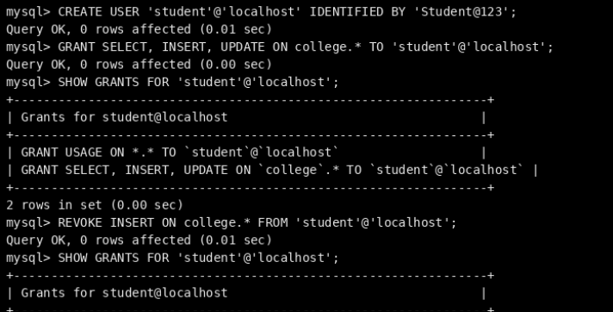
RESULT:
Thus the DCL commands GRANT and REVOKE SQL executed successfully.

